Test case

Description:sự mô tả

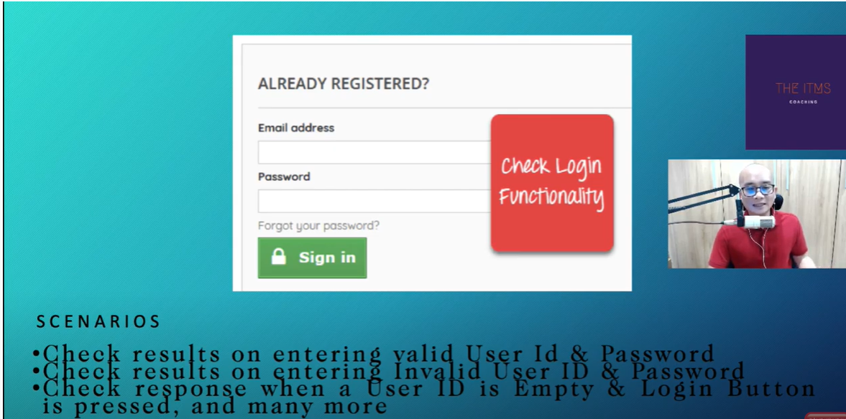

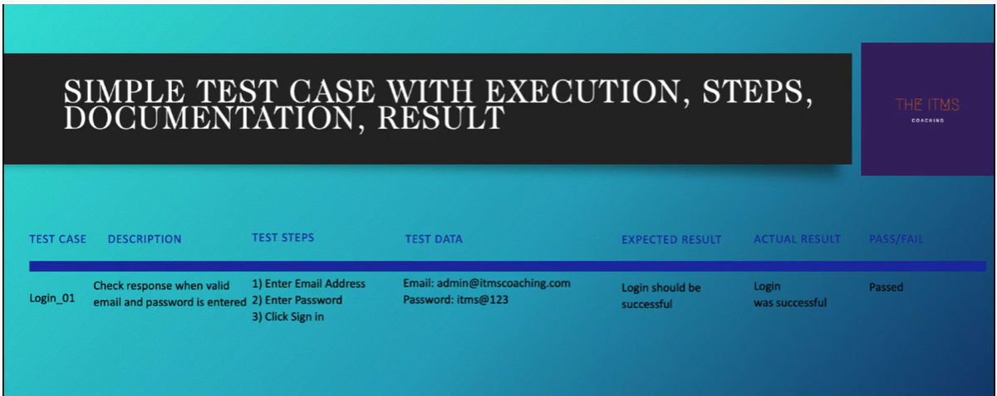

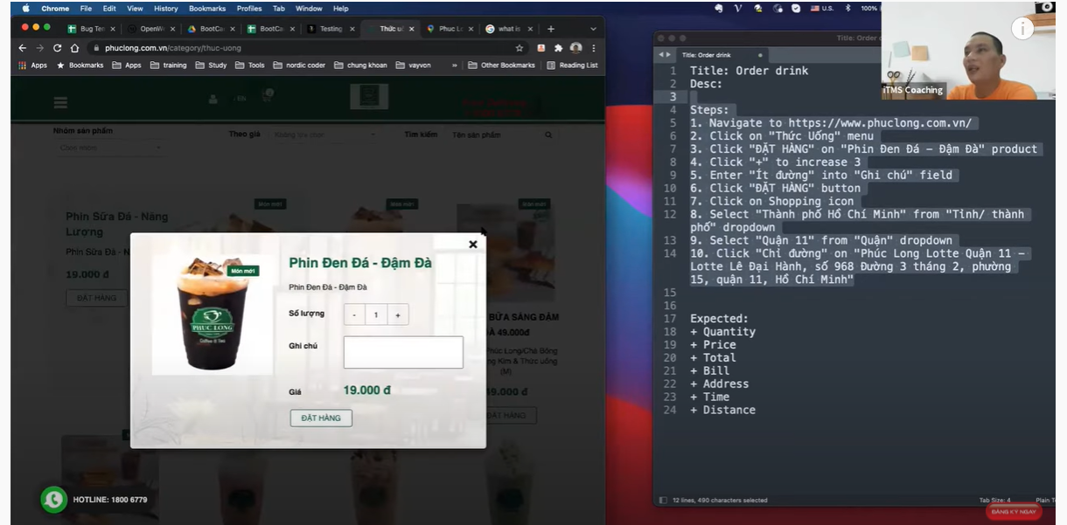

Ví dụ :<https://www.youtube.com/watch?v=k1lSrYxBHNw>